Earthquakes
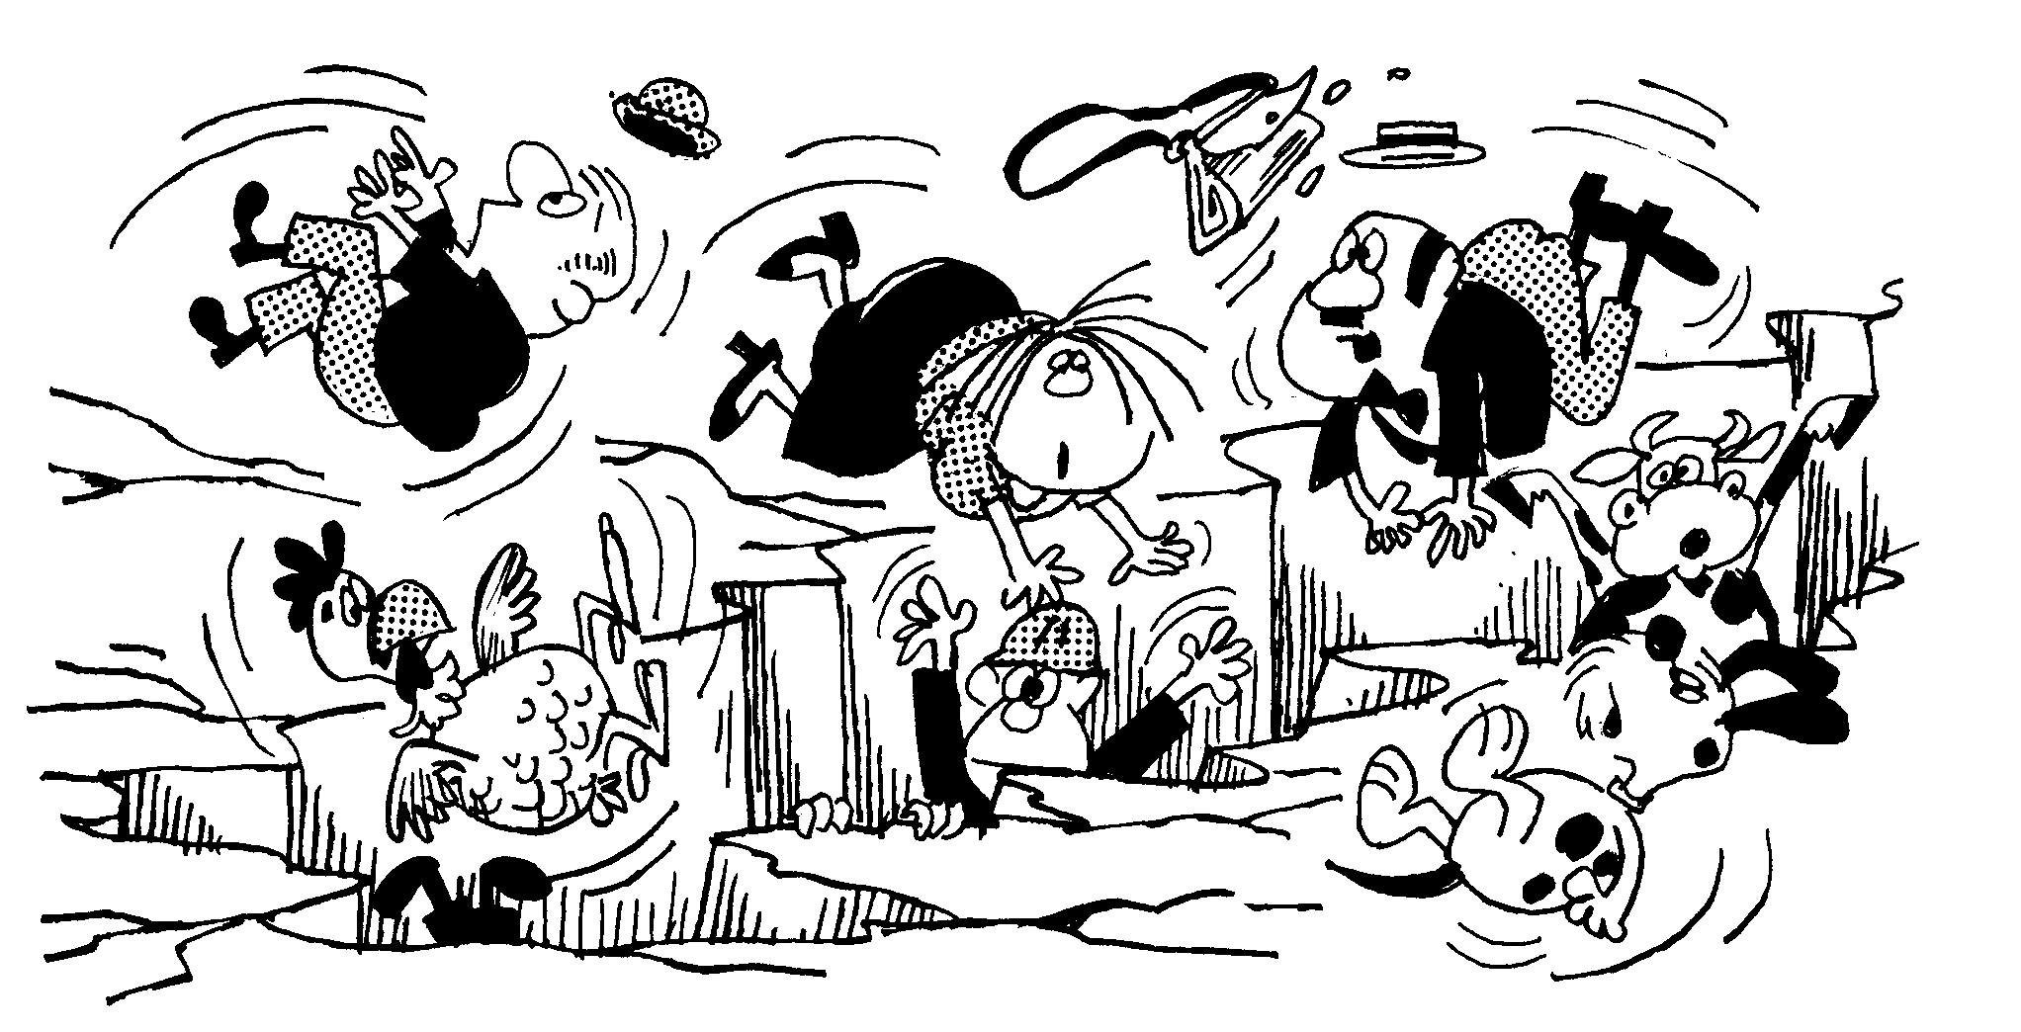
Information
Earthquake= a sudden and rapid movement of the ground.

Measuring
Earthquakes are measured by machines called Seismometers. The unit of measure is points on the Richter scale. Each time the Richter scale increases by one the force of the earthquake increases by ten.

Waves
The shaking occurs in waves. These waves are called Seismic waves. There are three types of Seismic wave:
P-waves=these waves move backwards and forwards (longitudinally) in the Earth.
S-waves=these waves move up and down (transversely) in the Earth.
Surface waves=waves moving along the Earth’s surface. These cause the most damage.

Where they start
Earthquakes occur most often at fault lines.
Focus=the place and earthquake starts under the ground.
Epicentre=the place on the surface of the Earth directly above the focus. This is where most of the energy is released.

Effects
- The ground surface deforms (changes shape).
- Buildings fall down. Most earthquake-related deaths are caused by the collapse of structures.
- Bridges fall down.
- Landslides where large pieces of land slide downwards
- Tsunamis, which is when large waves are caused by the earth moving under water
- Fires started by gas and other fuel lines being broken.
- Sewage pipes burst. Apart from being smelly this increases the chances of people getting sick after the earthquake.
- Water pipes for drinking water burst.
- Flooding caused as dams burst.
- Breakdown in communication systems, both because wires are damaged and there is no power.
- Transport networks disrupted.
- Power supplies disrupted.
- Looting.
Questions
Earthquake= a sudden and r__________ movement of the ground.
Measuring
Earthquakes are measured by machines called S_______________. The unit of measure is points on the R___________ scale. Each time the Richter scale increases by one the force of the earthquake increases by t__________.
Waves
The shaking occurs in ________. These waves are called S_______ waves. There are three types of Seismic wave:
P-waves=these waves move backwards and f_________ (longitudinally) in the Earth. Draw a diagram of a P wave:

S-waves=these waves move up and down (t_______________) in the Earth. Draw a diagram of an S wave:

Surface waves=waves moving along the Earth’s __________. These cause the most damage. Draw a diagram of a surface wave:

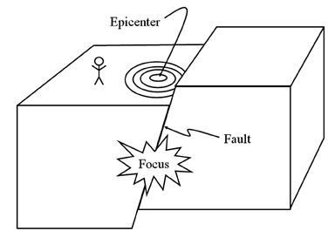
Where they start
Earthquakes occur most often at ___________ lines.
Focus=the place and earthquake ___________ under the ground.
Epicentre=the place on the surface of the Earth directly above the __________. This is where most of the energy is released.
Why is the epicentre not always the place where the fault can be seen on the surface?
Effects
- The ground surface d___________ (changes shape).
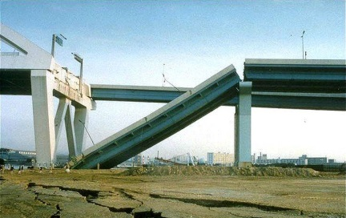
- Buildings fall down. Most earthquake-related deaths are caused by the collapse of _______________.
- Bridges fall down.
- L_________________
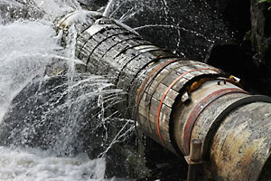
- Large waves called __________________ may hit coastal areas
- Fires started by __________ and other fuel lines being broken.
- Sewage pipes burst. Apart from being smelly this increases the chances of people getting ______________ after the earthquake.
- ___________________ for drinking water burst.
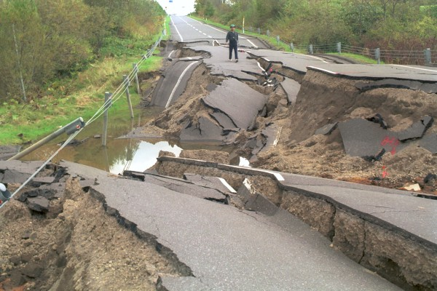
- Flooding caused as _______________ burst.
- Breakdown in _________________ systems.
- As roads are damaged or have rubble on them _________________________ are disrupted
- Power supplies disrupted
- Looting.

Why do you think power supplies are disrupted?

What may be some effects of burst water pipes?

What do you think looting means?

Why do you think looting happens at this time?

Irpinia earthquake
At the epicentre of and earthquake the release of energy on the surface is greatest. As the energy moves away from the epicentre the waves spread out in concentric circles. As the waves move they lose energy. Look at the diagram below and use it to answer the questions that follow.
The 1980 Irpinia earthquake took place in the Irpinia region in Southern Italy on Sunday, November 23, 1980. Measuring 6.89 on the Richter Scale, the quake, centered on the village of Conza, killed 2,914 people, injured more than 10,000 and left 300,000 homeless. 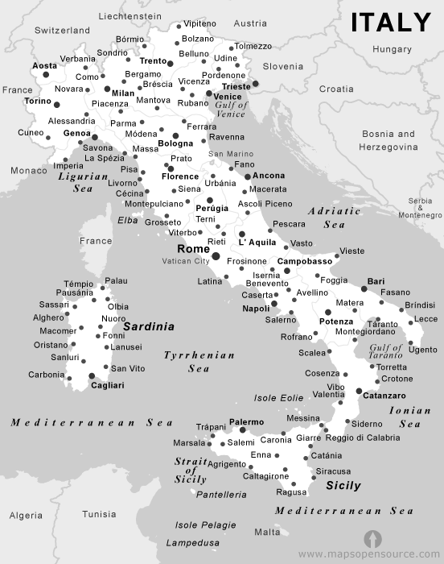
Place the following towns and cities in order of which would have received the greatest seismic force from the Earthquake. Give a reason for your answer.
Napoli(Naples), Rome, Potenza, Conza and Siena.

Why did more people die in the towns than in the country? Give two reasons.

Earthquake

D | F | R | R | E | T | H | C | I | R | R | Y | T | F | S
Q | I | P | W | L | E | O | A | G | E | D | L | S | A | M
G | E | L | S | G | L | B | F | T | J | G | E | U | U | A
Z | H | W | A | L | R | P | E | L | A | C | S | N | L | D
Z | E | W | A | F | O | M | N | M | V | C | R | A | T | R
Y | E | P | O | V | O | L | W | R | S | Z | E | M | I | O
S | S | C | L | M | E | W | X | O | J | B | V | I | Y | Q
E | U | W | S | A | E | S | X | F | G | V | S | S | W | G
S | Z | E | K | X | N | C | Y | E | L | S | N | J | Y | Q
T | I | U | N | O | S | D | A | D | Y | B | A | F | P | G
S | O | I | X | B | H | F | S | F | L | Z | R | D | A | H
A | R | O | Q | A | K | D | A | L | R | B | T | X | S | X
N | K | W | L | U | H | H | G | B | I | U | L | F | M | M
E | P | I | C | E | N | T | R | E | Y | D | S | K | U | Y
N | R | A | P | I | D | X | B | K | S | Y | E | C | Y | K

COLLAPSE |  |  | DAMS | DEFORM
EPICENTRE |  |  | FAULT | FOCUS
LANDSLIDE |  |  | LOOT | RAPID
RICHTER |  |  | SCALE | SEWAGE
SIESMOMETER |  |  | SURFACE | TRANSVERSELY
TSUNAMIS |  | WAVES


